Register a device

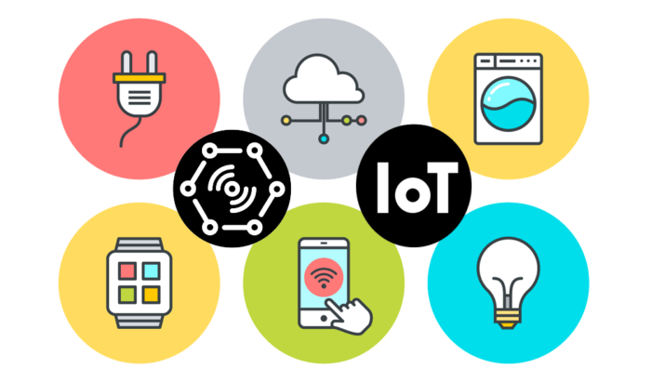

Register a device

A device must be registered with your IoT hub before it can connect.

In this slide, you use the Azure Portal to register a simulated device.

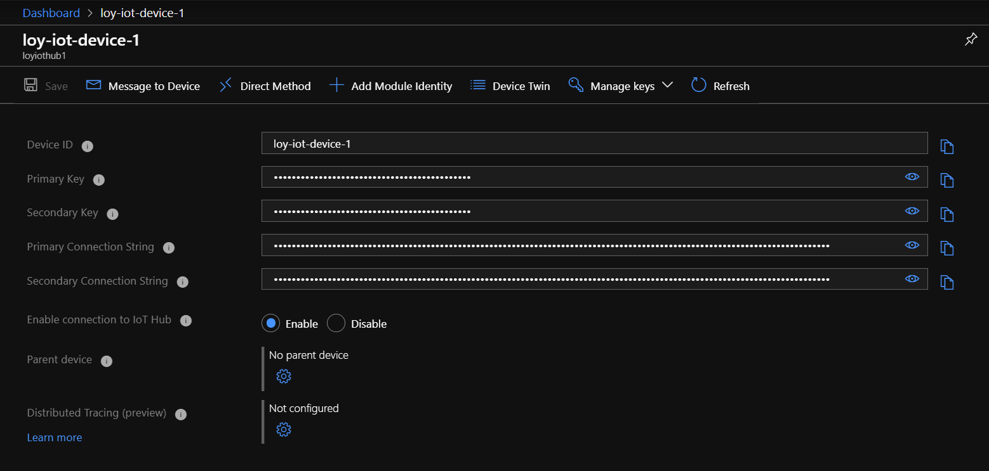

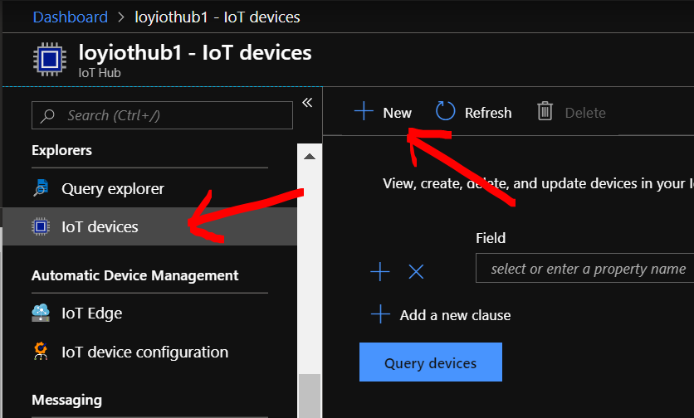Go to IoT Hub

In Explorers click IoT device

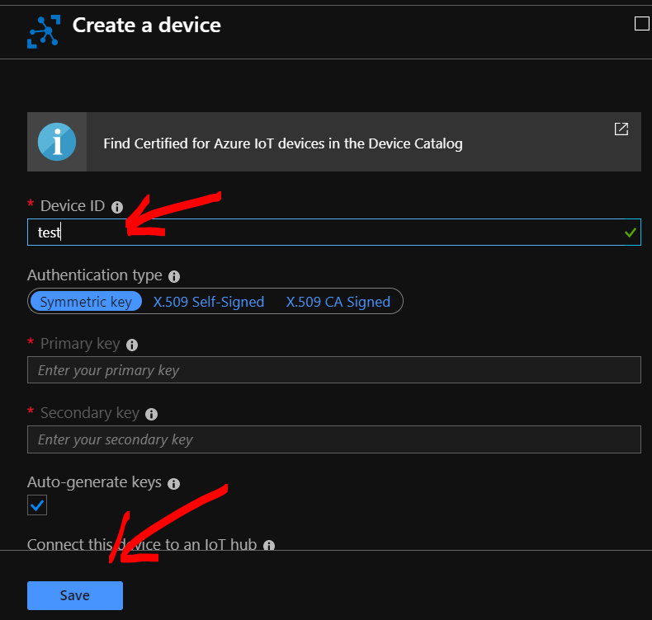Enter Device ID and Save

What's next?

